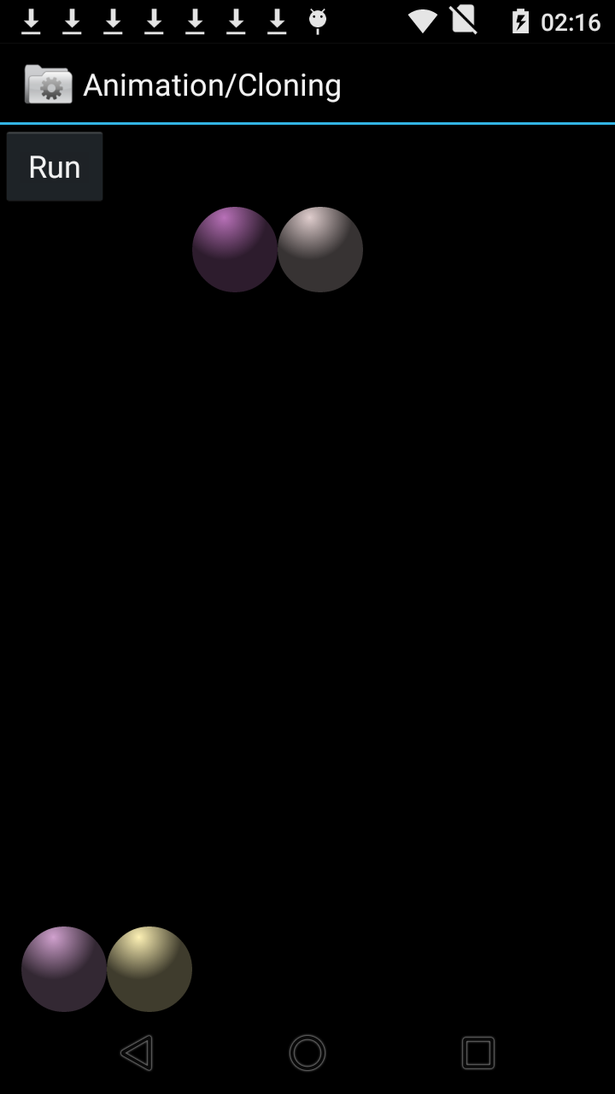

//设置ball1的动画

ObjectAnimator anim1 = ObjectAnimator.*ofFloat*(balls.get(0), "y",

0f, getHeight() - balls.get(0).getHeight()).setDuration(500);

//克隆ball1的动画，给ball2

ObjectAnimator anim2 = anim1.clone();

anim2.setTarget(balls.get(1));

anim1.addUpdateListener(**this**);

//设置ball3的动画，下降时加速，上升时减速

ShapeHolder ball2 = balls.get(2);

ObjectAnimator animDown = ObjectAnimator.*ofFloat*(ball2, "y",

0f, getHeight() - ball2.getHeight()).setDuration(500);

animDown.setInterpolator(**new** AccelerateInterpolator());

ObjectAnimator animUp = ObjectAnimator.*ofFloat*(ball2, "y",

getHeight() - ball2.getHeight(), 0f).setDuration(500);

animUp.setInterpolator(**new** DecelerateInterpolator());

AnimatorSet s1 = **new** AnimatorSet();

s1.playSequentially(animDown, animUp);//先下降，再上升

animDown.addUpdateListener(**this**);

animUp.addUpdateListener(**this**);

//克隆ball3的动画，给ball4

AnimatorSet s2 = (AnimatorSet) s1.clone();

s2.setTarget(balls.get(3));

animation = **new** AnimatorSet();

//ball1,ball2,ball3一起播放

animation.playTogether(anim1, anim2, s1);

//ball3 动画播完后，再播ball4的动画

animation.playSequentially(s1, s2);